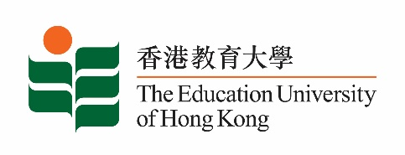
致： 传媒机构采访主任 (共 2页) 17 December 2021
To : News Editors (total: 2 pages)

香港教育大学2021年12月20日至2022年1月2日可供采访之活动一览
The Education University of Hong Kong (EdUHK) Events Calendar for 20 December 2021 to 2 January 2022
本校诚邀 贵机构派员采访下列活动。传媒查询，请联络教大传讯处（电话：2948 6050）。
You are cordially invited to cover the events below. For media enquiries, please contact the Communications Office at 2948 6050.

因应2019冠状病毒疫情，以下活动或有人数限制，传媒请预先向主办部门登记。
In light of the COVID-19 pandemic, there may be restrictions on the number of participants for the following event(s). Please contact the respective organiser(s) / department(s) for prior registration.

- 教大大埔校园 （新界大埔露屏路十号） / EdUHK Tai Po Campus (10 Lo Ping Road, Tai Po, New Territories)

日期  Date | 时间  Time | 活动  Event | 地点  Venue | 主办部门及公众查询  Organiser &  Public Enquiry | 备注  Remarks
2021-12-10-  2021-12-30 | 10 am –  6 pm | STEAM教学设计及成果展  STEAM Teaching Design and Achievements Exhibition | 教大大埔校园  文化与创意艺术学系展览厅(B2-P-01)  CCA Art Gallery, EdUHK Tai Po Campus (B2-P-01) | 主办部门 / Organiser:  文化与创意艺术学系  Department of Cultural and Creative Arts  查询 / Enquiries:  钟小姐 Miss Zhong  电邮 / Email:  szhong@eduhk.hk  电话 / Tel :  2948 6883 | 免费入场，  敬请预约。  Free admission.  By appointment.  详情/ Details:  https://www.facebook.com/eduhkcca/photos/a.806934382699416/4783467308379417/
2021-12-22 | 3 – 4 pm | FlipaClip网上工作坊  FlipaClip Online Workshop  主持 / Moderator:  黄素兰博士  Dr Wong So-lan  导师 / Instructor:  严颖彤老师  Ms Rachel Yim Wing-tung | 在线讲座  ZOOM  (连结将于报名后发送)  (Zoom link will be provided after registration) | 主办部门 / Organiser:  文化与创意艺术学系  Department of Cultural and Creative Arts  查询 / Enquiries:  钟小姐 Miss Zhong  电邮 / Email:  szhong@eduhk.hk  电话 / Tel :  2948 6883 | 免费报名，欢迎各界人士参加。  Free Registration. All are welcome.  报名方法 / Registration:  https://forms.gle/piEm5AHbNWBREPHB6

